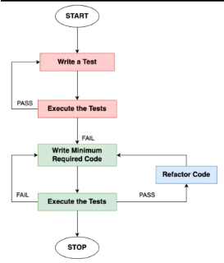

**## Test-Driven Development (TDD)**

**### The TDD Process**

1. *Write a failing test* for the new functionality you want to add

2. *Write the minimum amount of code* to make the test pass

3. *Refactor the code* to improve its design and structure

4. *Repeat steps 1-3* until all functionality is implemented

**### Benefits of TDD**

- *Reduces bugs* by catching issues early in the development process

- *Improves code quality* through refactoring and modular design

- *Provides clear documentation* of what the code is supposed to do

- *Enables faster development* by providing a safety net for changes

- *Fosters a test-first mindset* that leads to more reliable software

**### How TDD Improves Software Reliability**

- *Tests act as a safety net* for changes, allowing you to refactor with confidence

- *Modular, testable code* is easier to maintain and extend over time

- *Automated tests ensure regressions* are caught before they reach production

- *Focusing on testability* leads to better software design and architecture

- *Developers gain confidence* that the software works as intended